IT24104176 PS LAB6

1.

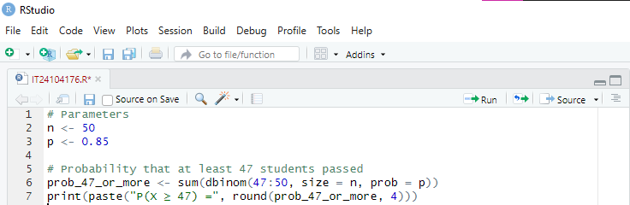

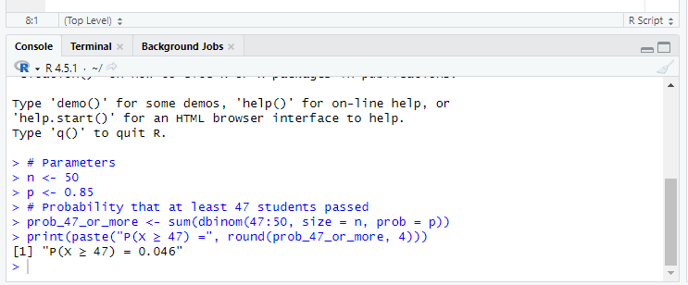

2.

